1. Introduction:

1.1. Label free imaging: Why to measure phase?
General trends in microscopy requires the samples to be stained or labelled with a dye. Staining works well because it makes the important structures in a cell absorb or emit light differently from their surroundings, which shows up clearly as differences in brightness and colour under a normal camera. The problem is that staining usually requires killing or chemically fixing the sample, or in the case of fluorescent labels, can be slow, expensive, and sometimes toxic to a living cell over time. If study requires imaging dynamic behavior like living cell moving, dividing, or responding to a drug in real time, staining fails.
Alternatively, cell does not need to absorb or emit light differently to be visible in principle. Even a completely transparent object can slightly change the timing (technically, the phase) of the light passing through it, because its internal density and composition are different from the fluid around it. This means a transparent, living, completely unstained cell is still, in a very real sense, full of visual information. The problem is that this information is invisible to an ordinary camera, which can only record intensity, not phase. Recovering it requires computational imaging for accurate label free applications.

1.2. How light interacts?
When light passes through or reflects off a sample, the sample can affect it in two distinct ways, and real samples usually do a mixture of both. An amplitude object absorbs some of the light passing through it, so different parts of the sample come out at different intensity levels. This is what a dye or stain does: it deliberately makes certain structures absorb light strongly, so they show up as dark regions against a lighter background. A phase object, by contrast, absorbs almost none of the light, but slows it down by different amounts in different places, because different parts of the sample have a different refractive index (a measure of how much a material slows light down compared to travelling through empty space or through water). A living, unstained biological cell is, to a very good first approximation, a pure phase object: it is nearly transparent, but its internal structures, the nucleus, organelles, and so on, have a slightly different refractive index from the surrounding fluid, and therefore slow light down by a slightly different, spatially-varying amount.
We describe the combined effect of a thin sample on the light passing through it with a single mathematical object called the transmittance function, written as a complex number at every point in the image:
$O\left(x,y\right)=A\left(x,y\right)e^{iφ}$
where A is the local amplitude transmission (how much light gets through) and $φ$is the local phase delay (how much the light's timing is shifted). A pure phase object has A equal to 1 everywhere, it lets all the light through and carries all of its structure in $φ$.

1.3. How lens forms an image?
A microscope objective lens has a finite size, and therefore can only collect light travelling within a limited range of angles from the sample. Because higher spatial frequencies in an object correspond to light bent off at steeper angles (fine detail scatters light more widely than coarse detail), a lens with a limited collection angle can only pass spatial frequencies up to some maximum value, everything finer than that is simply lost, forever, no matter how good the rest of the optical system is. This maximum angle is captured by a single number: the numerical aperture, or NA, which is essentially a measure of how wide a cone of light the lens can collect. A higher NA means a wider light-collecting cone, which means higher spatial frequencies are captured, which means finer detail is resolved. The relationship is direct: the highest spatial frequency a lens can pass is f_cutoff = NA divided by the wavelength of the light.

1.4. Lens and Camera
The lens is not the only thing that can throw away fine detail. A digital camera sensor is a grid of individual pixels, and a grid of finite pixel size has its own, completely separate limit on what detail it can faithfully record, described by the Nyquist-Shannon sampling theorem. Aliasing, can happen with fine spatial detail: if a pattern varies more quickly across space than the pixel grid can sample, the recorded image will show an incorrect, coarser, and sometimes actively misleading pattern instead of simply a blurred one.
A pixel grid of size p (referred to the sample, after accounting for the microscope's magnification) can only correctly represent spatial frequencies up to f_Nyquist = 1 divided by (2 times p). Crucially, this is a completely different, independent limit from the lens's NA-based cutoff. A microscope's actual, usable resolution is set by whichever of these two limits is smaller: a lens paired with a coarse sensor is bottlenecked by the sensor, and a fine sensor paired with a modest lens is bottlenecked by the lens.
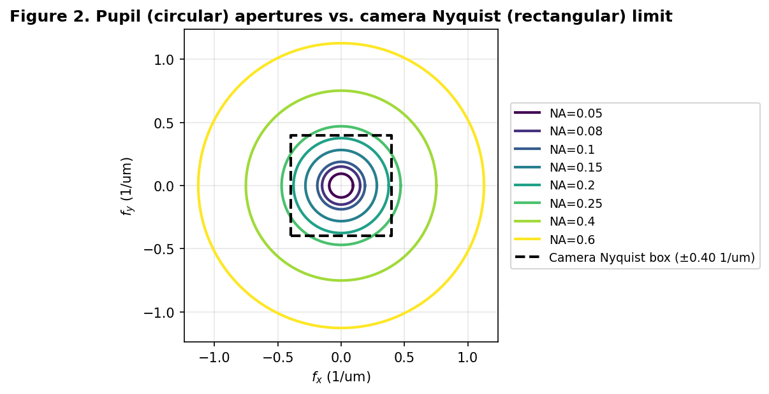
Figure 1. The lens's circular light-collecting aperture, drawn for several different NA values, plotted against the camera sensor's own fixed, rectangular Nyquist limit. Wherever the lens's circle extends beyond the sensor's box, the camera -- not the lens -- has become the true bottleneck.
For the specific simulation specifications, 532 nanometre green illumination, a camera with 2.5-micron pixels, and a system magnification of 2x, these two independent limits happen to become equal at NA = 0.213. Below this NA, the lens is the limiting factor; above it, the camera sensor is.

1.5. Fourier ptychography microscopy (FPM)
Establishing the trade-off: a microscope objective with a small FOV but high magnification typically has a high NA and therefore fine resolution, while a low-magnification, wide FOV lens typically has a lower NA and therefore coarser resolution. FPM is a computational technique that gets around this trade-off, without needing any lens hardware.
Instead of a single, fixed illumination source, the sample is lit from many different angles in turn, usually using a flat grid of LEDs positioned below it, each one switched on separately while a low-resolution image is captured. Illuminating from an angle, rather than straight on, has a very useful effect in Fourier terms: it shifts which part of the object's spatial-frequency spectrum falls within the lens's limited collection cone. Each low-resolution image captured under a different illumination angle contributes a different patch of the object's true, full spatial-frequency spectrum. A reconstruction algorithm stitches these overlapping patches back together into one synthetic spectrum that is much larger than what the physical lens could capture in a single shot, and transforming this larger, stitched-together spectrum back into an image yields a result with both the wide field of view of the original low-magnification lens and a resolution far exceeding what that lens could achieve on its own.

1.6. Focusing in microscopy
A microscope is in focus when the sample sits at the exact focal distance from the lens for which the optical system forms a sharp image at the detector. Move the sample even a small distance closer to or further from the lens, an error called defocus, and the image blurs. For an ordinary microscope, a human operator (or a simple hardware autofocus routine) adjusts a focus knob while watching the image, stopping when it looks sharpest.
FPM's reconstruction algorithm is iterative: it starts from a rough estimate and repeatedly refines it, and like most iterative algorithms, it needs a reasonably accurate starting guess to succeed. One of the numbers it needs as a starting guess is exactly how far out of focus the sample was when the low-resolution images were captured. If this starting guess is badly wrong, the reconstruction can develop artifacts, or fail to converge to a good answer at all. Because FPM already has all the raw low-resolution images captured under different illumination angles, it is natural to estimate this defocus computationally, directly from those images, rather than relying on a separate hardware autofocus step -- but doing so correctly requires understanding exactly how defocus changes an image, which is the subject of the next two sections.

1.7. Defocus phase factor
Once we know an object's full spatial-frequency spectrum at the correct focal plane (whether captured directly or, as in FPM, reconstructed computationally), we can calculate what the same light would look like at a nearby plane, a distance z away, using a method called angular spectrum propagation. Physically, each spatial frequency component of the light can be thought of as a plane wave travelling at a slightly different angle, finer spatial detail corresponds to steeper travel angles. Moving a distance z along the optical axis advances each of these plane waves' phase by a different amount, depending on how steep an angle they are travelling at. Recombining all these separately-shifted plane waves reconstructs the field at the new, defocused plane. Mathematically, this means multiplying the spectrum by a phase factor exp[i * z * kz(fx,fy)], where kz depends on the spatial frequency (fx,fy) and the wavelength; the exact formula, kz = 2*pi*sqrt(1/lambda^2 - fx^2 - fy^2), is not important to memorise, only the physical picture behind it: simulating defocus is nothing more than letting each spatial-frequency component's clock run differently for a distance z, then adding them back together.

1.8. Transport of Intensity Equation
Consider a pure phase object, $O\left(x,y\right)=e^{iφ}$. Exactly at the true focal plane, the intensity recorded by a camera is, to a very good approximation, completely uniform equal to 1 everywhere, no matter how much real structure phi actually contains. A cell that is, packed with visible internal detail can appear as a flat, featureless grey blob in an ordinary in-focus photograph, purely because none of that detail has yet been converted from phase information into intensity information.
This conversion process is described precisely by a result called the Transport of Intensity Equation (TIE): the rate at which the recorded intensity changes as you move the focal plane along the optical axis is proportional to the local curvature of the object's phase profile, roughly speaking, how sharply the phase is bending. Defocusing a phase object is therefore not simply a matter of blurring away detail; it is actively converting previously invisible phase structure into visible intensity structure. This is exactly backwards from the everyday intuition that more defocus always means a worse, less detailed image, and it is the single physical fact responsible for every unusual result described later: for a phase object, moving away from focus can genuinely increase image contrast, for a while, before the more familiar geometric blurring eventually takes back over and washes the contrast out again. The competition between these two effects -- rising phase-driven contrast, and growing ordinary blur -- shapes everything that follows.

1.9. Sharpness metric: Brenner gradient
A blurred image lacks fine edges, while a sharp image is full of them. To automate this judgement, we need a single number, computed from an image, that tends to be larger when the image is sharper and smaller when it is blurred, called a sharpness metric or focus measure. One of the oldest and simplest such metrics is the Brenner gradient (Brenner et al., 1976), which compares each pixel's brightness to another pixel a small, fixed distance away (traditionally two pixels), squares the difference, and adds this up over the whole image:
The idea is straightforward: in a sharp, high-contrast image, neighbouring pixels often differ substantially in intensity; in a blurred image, neighbouring pixels look nearly the same as each other everywhere. Squaring and summing these differences gives a single number that is large for a sharp image and small for a blurred one. The specific two-pixel gap, rather than comparing immediately adjacent pixels, is a deliberate design choice: it is wide enough to avoid being fooled by random, single-pixel sensor noise, while still being narrow enough to respond strongly to genuinely sharp edges. Ordinary autofocus software sweeps a range of candidate focus positions z, computes B(z) at each, and picks the z that gives the largest value. A recurring theme is that this simple, effective strategy needs to be revisited carefully once the object being focused on is a phase object rather than an ordinary, absorbing one.

1.10. Sampling and aliasing
Every quantity discussed: the object, its spectrum, the propagation phase factor, the final image must, when studied by computer simulation, be represented on a finite grid of discrete numbers rather than as smooth, continuous mathematics.
The propagation phase factor from Section 1.7. is, mathematically, what is called a chirp: a wave whose local oscillation rate increases as the defocus distance z grows larger. Push the simulated z far enough, for a high enough spatial frequency, and this chirp will change by more than half a cycle between one grid sample and its immediate neighbour. Past that point, the discrete calculation can no longer represent the true, continuous physics correctly, and will silently produce a wrong answer with no obvious warning sign that anything has gone wrong.
The reason this matters enough to flag explicitly, rather than simply trusting the simulation by default, is that the defocus range out to several hundred microns. Before trusting any result over that wider range, we first work out exactly how far the simulation can safely go, and then use an established correction technique that keeps the calculation accurate beyond that point.

2. Methodology
With the necessary background established, this section describes, in plain terms, exactly how the simulated microscope used throughout was built.

2.1. Simulated Hardware
The following table lists the physical parameters chosen to represent a realistic, modest FPM set-up, matched to commercially available components.
Quantity | Value used
Wavelength of illumination | 0.532 um (green light, 532 nm)
System magnification | 2.0x
Camera pixel pitch | 2.5 um (equivalent to 1.25 um at the sample plane)
Camera's own Nyquist limit | 0.40 spatial cycles per micron
Lens/camera crossover NA | 0.213
Simulated camera image size | 128x128 pixels (initial experiments), 256x256 pixels (later, extended-range experiments)
Lens NA values tested | 0.05, 0.08, 0.10, 0.15, 0.20, 0.25, 0.40, 0.60

2.2. Object Modelling
Each simulated sample is a complex transmittance function, built from two standard, freely available test images: an amplitude pattern A taken from a classic photographic test image and a phase pattern phi taken from a smoothed photograph of the Moon's surface (chosen simply because it provides smoothly-varying, natural-looking texture rather than sharp geometric edges, similar in character to real cell structure). The constant c sets how strongly the phase pattern affects the light, and defines the object categories used throughout this review: a pure amplitude object (c = 0, behaving like an ordinary stained sample), a weak phase object (small c, representing a thin, only mildly refractive cell), a strong phase object (larger c), a sharp-edged phase object, and two combined objects containing both amplitude and phase structure at once.
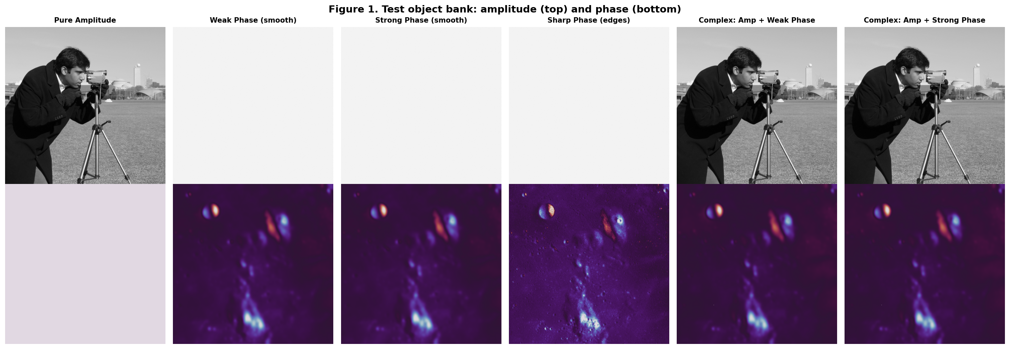
Figure 2. The full set of simulated test samples used throughout this review. Top row: the amplitude (intensity-affecting) part of each sample. Bottom row: the phase part of the same sample.

2.3. Defocus modelling
Defocus is simulated exactly as described conceptually in Section 1.7.: the sample's spectrum is computed once, the portion of that spectrum the simulated lens would actually collect is selected, the defocus phase factor is applied, and the result is transformed back into a simulated camera image. For the later experiments covering a very wide range of defocus distances, an additional safety correction (following Matsushima and Shimobaba, 2009) is applied at every simulated defocus distance: any individual spatial frequency whose local propagation phase would violate the sampling limit is deliberately switched off for that one calculation, protecting the simulation from silently computing wrong answers, while leaving every other, safely-sampled frequency untouched.

3. Results

3.1. Sharpness metric
Section 1.9. introduced the Brenner gradient as a simple, sensible way to measure sharpness. It might seem like a small implementation detail exactly how this number is calculated, for instance, whether each individual defocus image's brightness is rescaled to fill a standard range before the gradient is computed, purely for convenience of plotting or comparison. After comparing the plain Brenner gradient (as defined in Section 1.9., with no rescaling) against a rescaled version, for a weak phase sample at a moderate NA of 0.20, and the two give visibly different, incompatible pictures of the same underlying data.
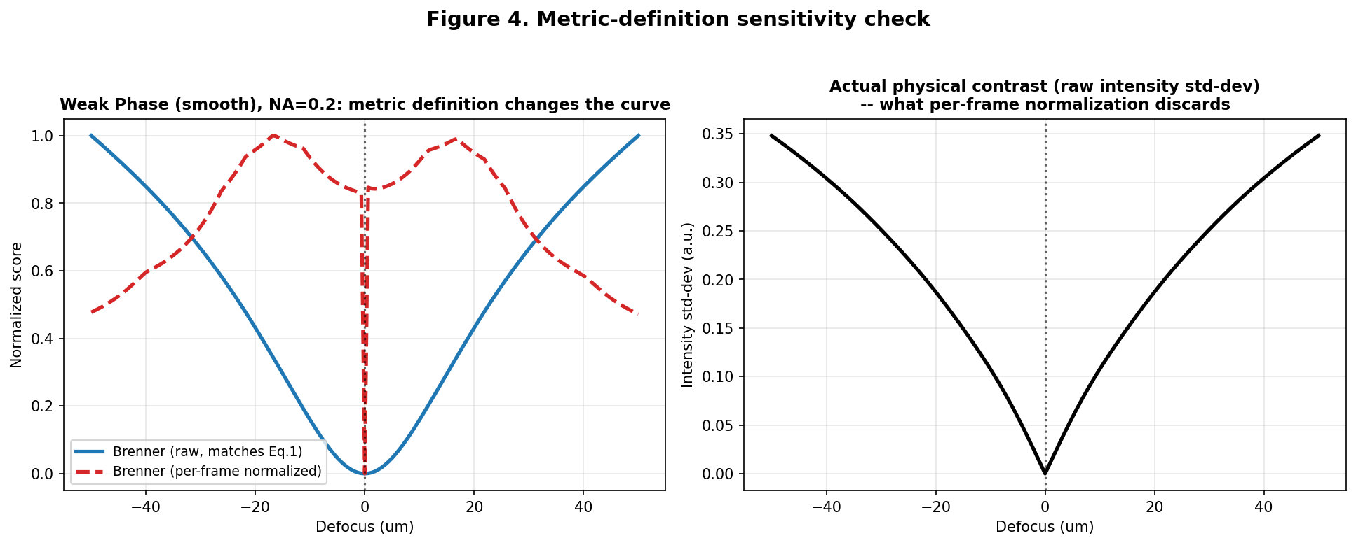
Figure 3. Left: the plain Brenner curve (blue) compared against a per-image-rescaled version (red, dashed), for the same simulated data. The two disagree sharply -- the rescaled version even shows a false double-peak shape the plain version does not. Right: the true, unscaled physical contrast in the image at each defocus distance, which the rescaling step discards.
The right-hand panel of Figure 3 explains why this happens. The true physical contrast in the image, right at the point of best focus, is only about 0.025% of the largest contrast found anywhere else in the sweep -- in other words, the in-focus image really is close to featureless, exactly as Section 2.9 predicts for a phase object. Rescaling every individual image's brightness to fill the same fixed range before measuring sharpness erases this enormous, genuine difference in signal strength, and can manufacture the appearance of structure in the sharpness curve that has nothing to do with real optical behaviour.
With this one clarified definition, a single, consistent set of sharpness curves was generated for every combination of sample type and lens NA described in Section 3.
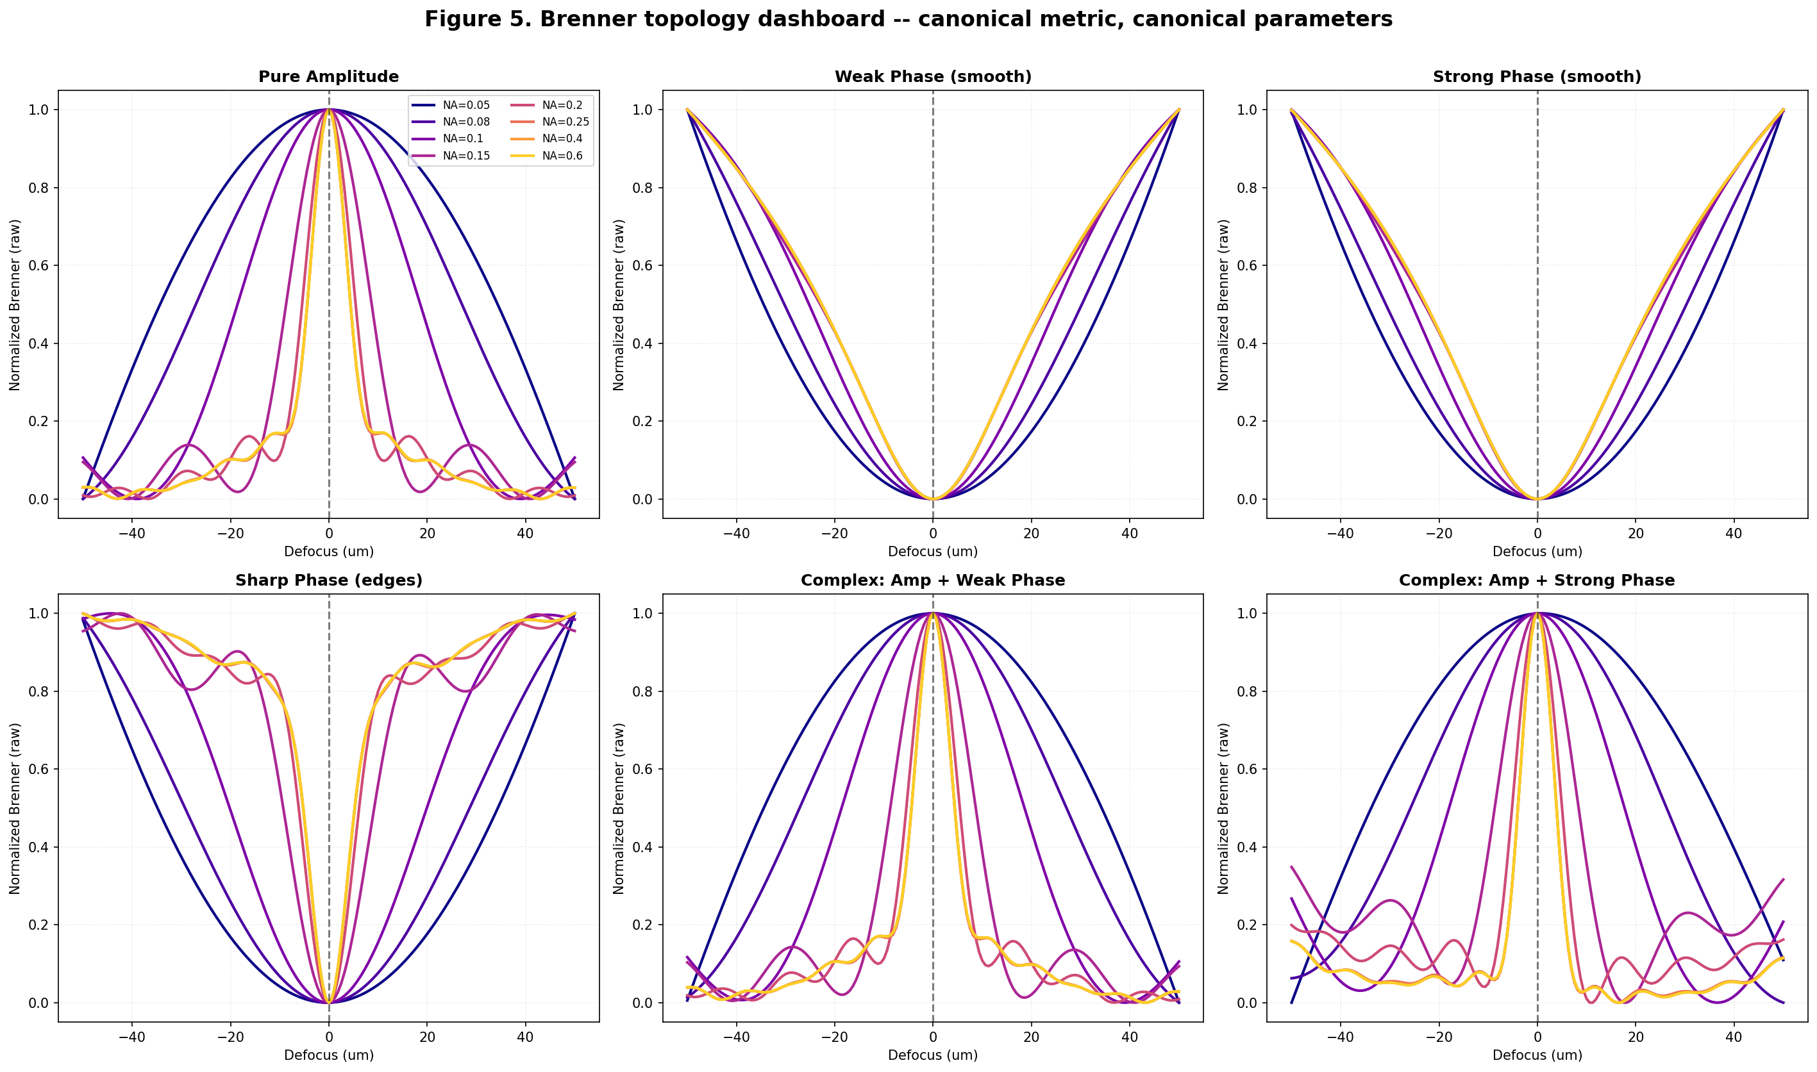
Figure 4. Brenner sharpness curves for all six sample types (Figure 2), across all eight tested lens NA values, using the corrected, plain definition of sharpness from Section 2.10. The horizontal axis is defocus distance; the vertical axis is sharpness, normalized so the largest value in each curve is 1.
For the pure amplitude sample (top-left panel), sharpness peaks cleanly at zero defocus, exactly as ordinary autofocus intuition expects. For the phase samples, sharpness is instead lowest at zero defocus and rises on either side -- a direct visual confirmation of Section 2.9's claim that a phase object is least visible exactly when correctly focused, and becomes more visible as it is defocused in either direction.

3.2. Anomaly Correction
An earlier stage of this project's analysis suggested something dramatic happening at high NA: a claim that the focus curve for a phase sample could switch character entirely at sufficiently high NA, from a genuine dip at true focus (as in Figure 4) to a deceptive false peak, an effect attributed to a well-known optical phenomenon called Gibbs-phenomenon ringing (a kind of overshoot that can occur whenever a sharp, abrupt cutoff -- such as the lens's own NA-based frequency cutoff from Section 2.4 -- truncates a signal). Before accepting a claim this dramatic, two more basic questions needed answering: was the underlying computer simulation even accurate enough, at high NA, to be trusted (see Section 2.11 on simulation sampling limits), and was the tool used to detect this claimed switch in character actually capable of seeing it?
On the first question, the same high-NA calculations were repeated at a finer simulation resolution and compared.
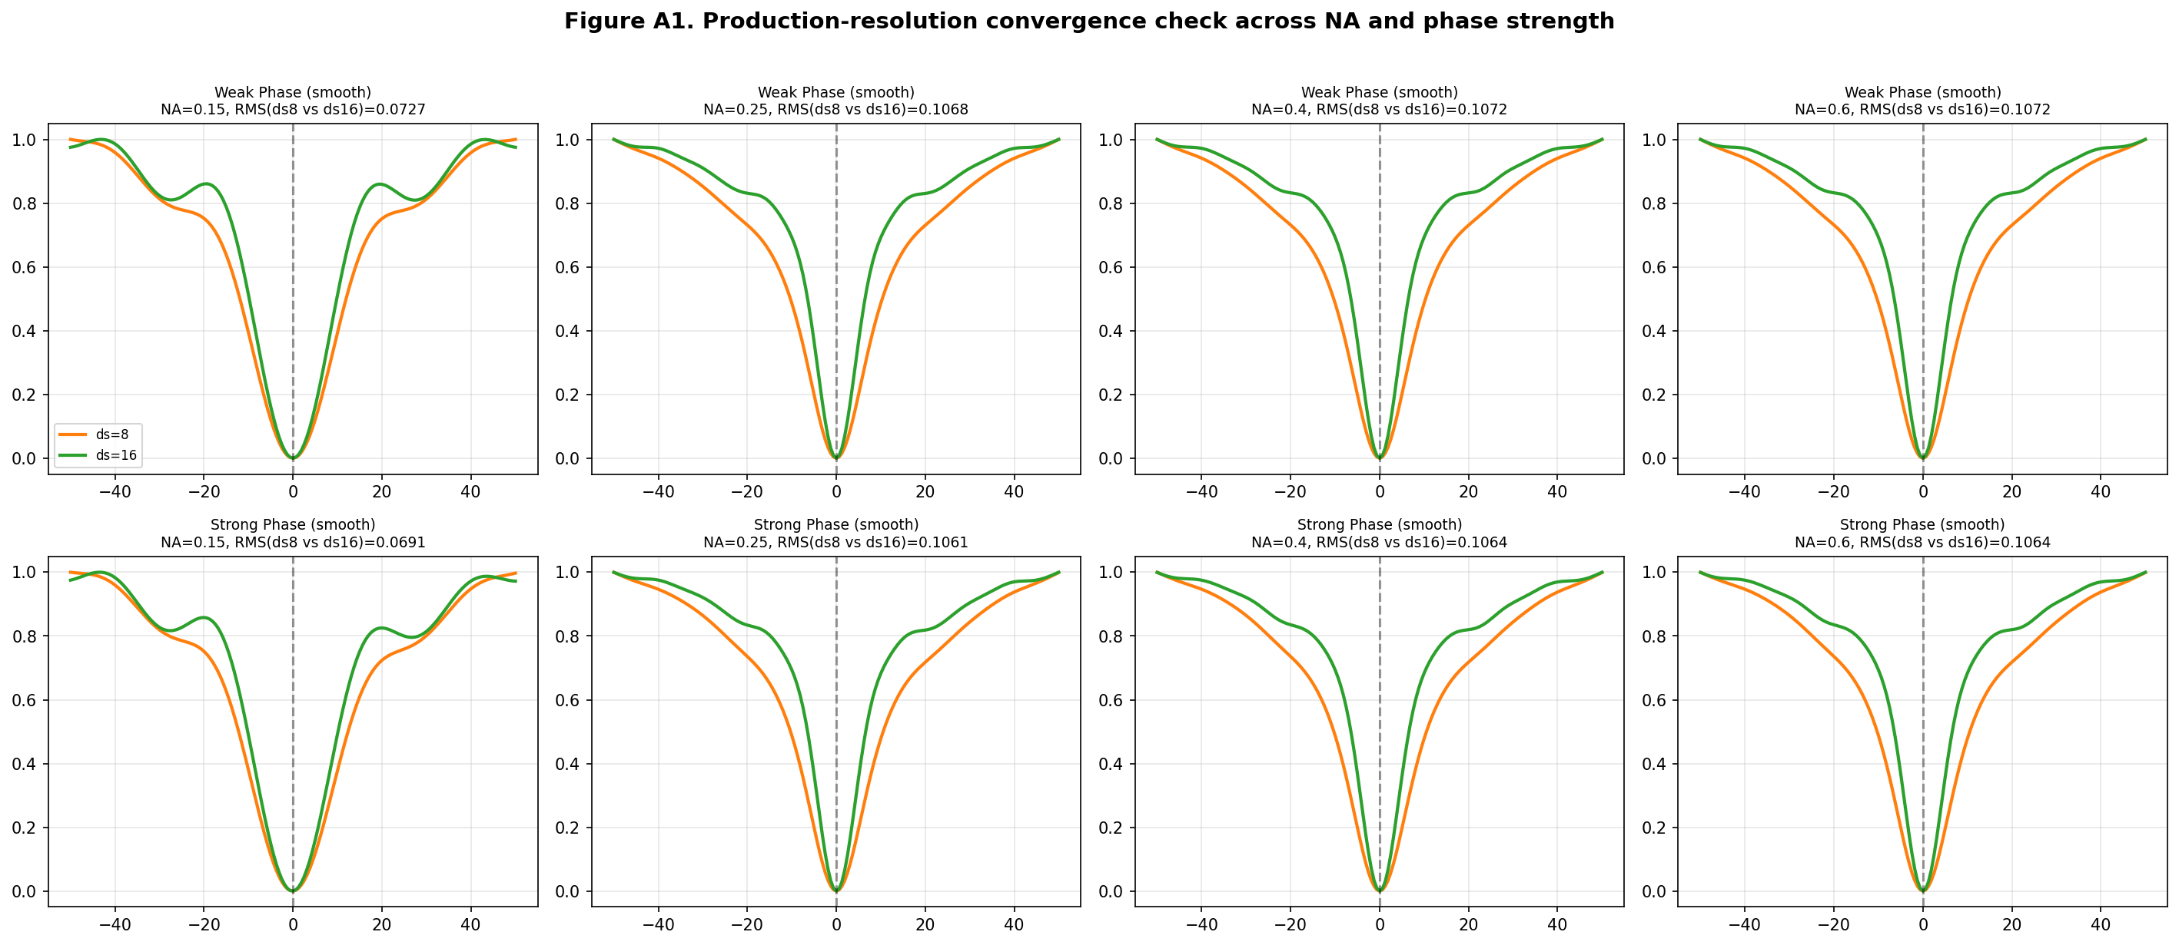
Figure 5. The same sharpness curves recalculated at two different simulation resolutions (a coarser one, orange, and a finer one, green), for four lens NA values and two phase strengths. Where the two colours overlap closely, the coarser resolution can be trusted; where they visibly separate, it cannot yet be trusted.
The two resolutions still differ by up to about 11% in the worst case, meaning the original, coarser simulation resolution was not yet fully trustworthy for fine claims about curve shape at high NA -- an important, if somewhat unglamorous, piece of due diligence.
On the second question, a proper multi-scale sharpness-shape detector was built: rather than checking the curve's shape using only one, narrow window of nearby defocus values (as the earlier analysis had done), three separate windows of increasing width were checked independently, for every sample type and every NA.
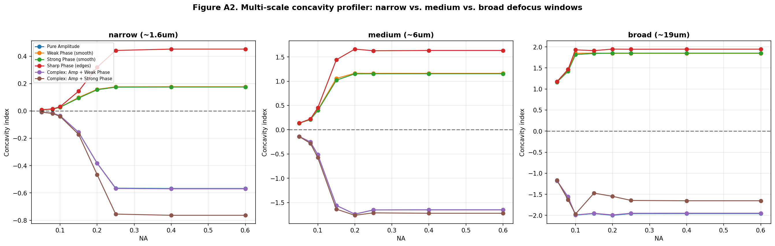
Figure 6. A measure of the sharpness curve's local shape near true focus (positive values mean a genuine dip, matching Section 2.9's expectation; negative values would mean a false peak), calculated at three different window widths, for every sample type and every tested NA. No combination shows a sign change at any width.
Every phase sample shows a genuine dip at true focus, at every window width and every tested NA; every amplitude-containing sample shows a genuine peak. No false-peak switch was found anywhere in the range actually tested. Taken together with Figure 5, the most likely explanation is that the earlier, dramatic claim reflected the metric-definition mistake described in Section 4.1, combined with inconsistent choices of defocus range in the original, less careful analysis -- rather than a real, physical optical effect. The correct, more modest and more defensible conclusion is that curve steepness and shape change substantially and continuously with NA, without a sudden, discrete switch in character.

